Nepal College of Information Technology
Balkumari, Lalitpur
Assessment-Fall 2009

Program: CE/ELX Time: 3 hrs
Semester: Fall FM: 100
Subject: Electronic Devices PM: 50
Attempt ALL the questions. Figures at the margin indicate their full marks.

1. a) What is avalanche breakdown? Derive an expression for ac resistance of a pn junction diode. [3+5]
b) Find the piecewise linear model of a silicon diode with I_{S} =10⁻¹¹A and η=1.6 in the vicinity of the operation point I_{D} =1mA. [7]
2. a) For a circuit given below, R_{S}=20Ω, V_{Z}=18V, R_{L}=200Ω. If V_{S} vary from 20V to 30V find
i) minimum and maximum current in Zener diode.
ii) minimum and maximum power dissipated in the diode.
iii) rated power dissipation that R_{S} should have. [8]
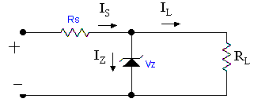
b) Explain how transistor works as an inverter. [7]
3. a) Compare CB, CC and CE configurations of BJT. [7]
b) Draw dc load line and determine the operating point. Assume the transistor to be made of Si. [8]
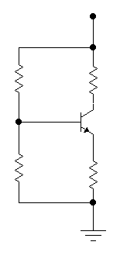
1KΩ
2KΩ
5KΩ
10KΩ
+V_{CC}=15V
4. a) Determine the expression for Ai, Zi, Av and Zo for the two-port device shown below in terms of h-parameter. [8]
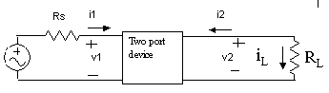

b) Find all the parameters for the given amplifier circuit. R_{L}=R_{C}=R_{S}=1KΩ,h_{ie}=1.1 KΩ, h_{re}=2.5X10⁻⁴ KΩ, h_{fe}=50, h_{oe}=25X10⁻⁶ mho. [7
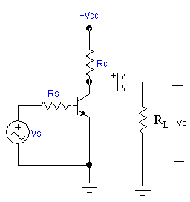

5. a) Explain the operation of N-channel JFET. What is pinch off voltage? Draw the transfer characteristic curves of N-channel JFET. [8]
b) For a given JFET in figure, I_{DSS}=10mA, V_{P}=-4V. Find drain current and drain to source voltage when V_{GS}=-15V. Assume it is biased in pinch off region. [7]
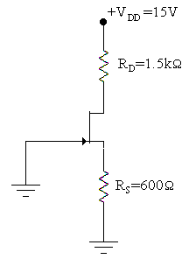
6. a) Draw full wave bridge rectifier circuit and explain its operation. Compare half wave rectification and full wave rectification in terms of ripple factor. [8]
b) Explain about clamper. [7]
7 Write short notes on (Any two): [2x5]
a) Tunnel diode
b) r_{e}- model of BJT
c) UJT

